**ABE 308 - Homework 6**

**Deadline Thursday April 19**

**Total 160 marks**

**Problem 1**

Agar can form a gel matrix that is commonly used to study the diffusion of polymers that are moved by electro kinetic movements with application to electrophoresis and immunodiffusion.

Consider an agar gel of 20 mm diameter containing a polymer with a uniform concentration of 0.15 kg/m3. Assume that the length of the cylinder is much larger than 20mm. The cylinder is suddenly immersed in water containing no polymer. The water flow is rapid enough to assume a negligible external mass convection resistance. The diffusivity of the polymer in in agar is 6 x10-10 m2/s.

(a) Calculate the concentration of the polymer at the center of the cylinder and at 5mm from the center after 20 hours of immersion.

(b) If the diameter of the cylinder is doubled what would be the concentration of the polymer at the center of the agar gel after 20 hours.

**Hint:** Use appropriate assumptions to solve this problem and clearly specify them. You can use the Heisler charts or the tables given in the summary of equations.

**[40 marks]**

**Problem 2**.

It is necessary to estimate how quickly the non-uniformities in gas composition in the pulmonary alveoli are damped out. Consider an alveolus to be spherical of diameter 0.1mm. Let the sphere has a uniform concentration of *ci* and at a certain instant its walls are raised to an oxygen concentration of *c∞*and maintained at this value. If the oxygen diffusivity in alveolus can be approximated as that in water and is equal to 2.4×10−9 m2 /s, how long does it take for the concentration change (*c−ci*) at the center to be 80% of the final concentration change?

**[20 marks]**

**Problem 3**

It is necessary to study the release kinetics of a drug from an uncoated resin sphere where all the mass resistance is diffusion in the sphere. Consider a sphere diameter of 100m. the initial amount of drug is 65mg/100 mg resin. The diffusivity of the drug in the resin is 3.4x10-9 m2/s. The surface of the sphere is maintained with zero drug concentration.

If 90% of the average drug concentration is released in 3 hours, what percentage of drug would be released in the same time when the diffusivity is halved while the diameter is reduced by a factor of. (Please note that 90% is an average concentration so you cannot use the Heisler charts, however you can use an analogy to the average concentration in a slab (just changing L by R) that was presented in lecture 11 for long times.

1. By using proper equations show what percentage of drug would be released fr these new values of diffusion coefficient and radius

**[20 marks]**

**Problem 4**

Dissolution of pharmaceutical tablets are normally tested by water flowing over the tablets that are submerged in vessels that are agitated under controlled conditions (see figure below). As indicated they are fixed a different distance from the center where agitation is different. It is desired the effect of locations on the dissolution rates for tablets that are not disintegrating (surface stays flat). For the study only the flow over the topflat of the surface is considered. For a rotational speed of N=50rpm of the impeller the bulk velocity of the water over the tablets can be calculated as *,* whereR is the radial location of the tablet. Length of the table along the flow is 1cm. The viscosity of the water is 0.8cP, density of water is 1000 kg/m3, and diffusivity of the drug in the water is 1.5x10-9 m2/s.

1. Find the mass transfer coefficient for the tablet at location 1
2. Find the mass transfer coefficient for the tablets at locations 2 and 3
3. Would the ratio of mass transfer coefficients between locations 1 and 2 change with the rotational speed, N?

**[40 marks]**

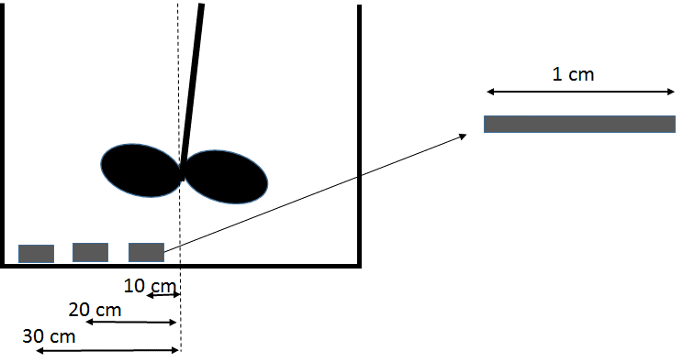

**Problem 5**

It is well known that when the ambient humidity is very high the cold is feeling less. The effect is known as the effect of air humidity on wind chill temperature. During a rainy day if your shirt gets wet probably you have already experienced that effect. Assume that the process is steady state and the rate of heat gain by your shirt is the same as the energy equivalent to the mass of water loss from evaporation and convection to the air.

1. Consider the shirt surface and write the amount of convective heat from the air (warmer) to the shirt (colder)
2. Write an equation to estimate the amount of convective moisture loss energy (due to the evaporation of the liquid water from your wet shirt) from the shirt surface to the air.
3. At steady state, equate equations in (a) and (b) and get an equation to predict the temperature of the shirt surface
4. Using Equation obtained in (c) shows that the temperature of the shirt surface will not feel as cold if the relative humidity of the air is higher.

**[40 marks]**